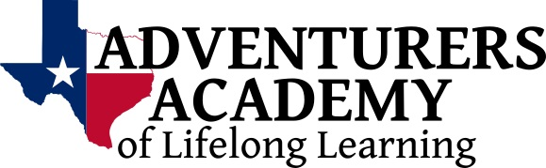

Annual Spring Fest & Silent Auction
Saturday, May 20, 2017

Thank you for sponsoring a table at Spring Fest 2017! You and your guests will have a great time while knowing you have helped adults with intellectual/developmental disability continue to learn, grow, and live a better life in our community!

Business or Organization Name
Click or tap here to enter text.
Contact Person
Click or tap here to enter text.
Contact Phone
Click or tap here to enter text.
Contact Email
Click or tap here to enter text.
Mailing Address
Click or tap here to enter text.

Description of your company (for use in the Spring Fest program, and in live announcements.)

Besides having a great time and helping to enrich the lives of the amazing Adventurers that are part of our program, with a sponsorship, your organization will receive:

$1000 8-Place Table Sponsorship  - 8 reserved seats at a table near the stage  - 8 buffet tickets | $600 4-Place Table Sponsorship  - 4 reserved seats at a table near the stage  - 4 buffet tickets
And
- Signage identifying your table and recognizing your organization’s sponsorship
- Your organization’s name displayed on signage near the stage
- Recognition by our emcee and/or musicians during the day’s event
- Gifts from the Adventurers!

